Summary:
Project to develop the Board Game ‘Reversi’ into a video game using Godot 4.1.2 for the purpose of practice and learning.

Contents:
Summary: 1
Contents: 1
Main Features 2
Controls 2
Storyboards 3
Implementation 6
Flowcharts 7

Main Features
Reversi is a game played between two people on an 8×8 grid typically using discs that have a dark side and a light side. Each player chooses one side to play as for the game. During The objective is to finish the game with the most discs in their colour. Discs cannot be placed in a space that is already occupied and a player’s turn ends when they make a move.
Reversi starts with an empty board. During each player’s first two turns, they must place their discs within the centre four spaces. Afterwards, they must place their discs so that they create a straight line (diagonal, horizontal, or vertical) that has one of their discs on both ends and at least one opposing disc between them. All opposing discs caught in the aforementioned line will be flipped to the current player’s colour. If such a line cannot be created, the player’s current turn will be skipped. The game ends when neither player can make any moves.
The game HUD should contain the turn number, which colour can currently make a move and how many discs each colour currently has. When the game ends, a game end screen should be displayed with the final totals and the winner of that game. A message should be displayed to tell the players when one player cannot make a move and which player this is. There should be indicators on each tile to show which tile is currently being hovered over. An indicator should be displayed if a player tries to make an illegal move.

Controls
The player will be able to pick a tile by; hovering over it using a mouse; moving to it using the ‘WASD’ or arrow keys on a keyboard; moving to it using the joystick or D-pad on a controller.
The player will be able to confirm their move by: left-clicking on a mouse; pressing the ‘E’ key on a keyboard; pressing the bottom button on a controller.

Storyboards
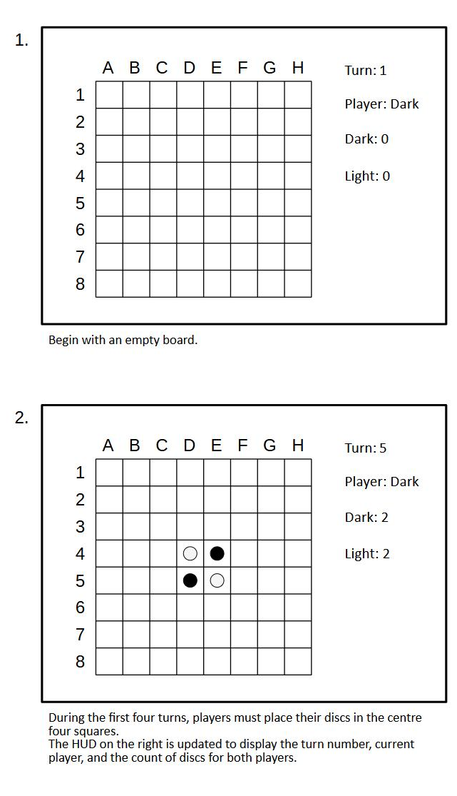
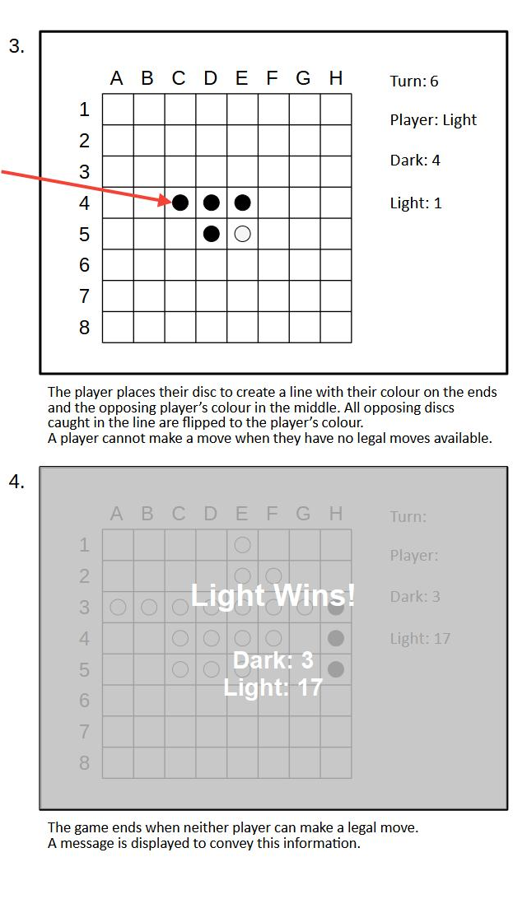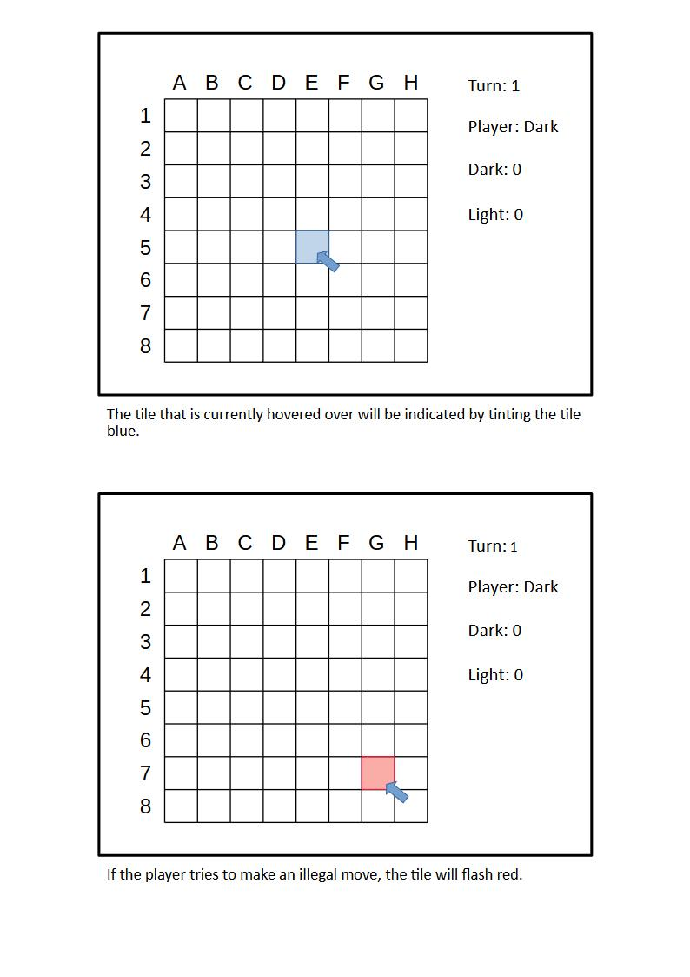

Implementation

Language
- GDScript

Software
- Godot v. 4.1.2
- Clip Studio Paint v. 2.0

Objects
- Tile(.place_disc(), .get_flippable_discs())
- Disc(.flip())

Scenes
- Game

Logic
- Flip Caught Discs(function, switch disc boolean)
- Calculate Discs that would be flipped by a move (function, use Vector2i)

User Interaction
- Move Between Tiles (direction input)
- Select Move (button clicked)

User Data
- Total Dark Pieces (integer)
- Total Light Pieces (integer)
- Turn Number (integer)
- Current Player Turn (boolean)
- Discs Flipped By Move (array)

Flowcharts

Overall Game
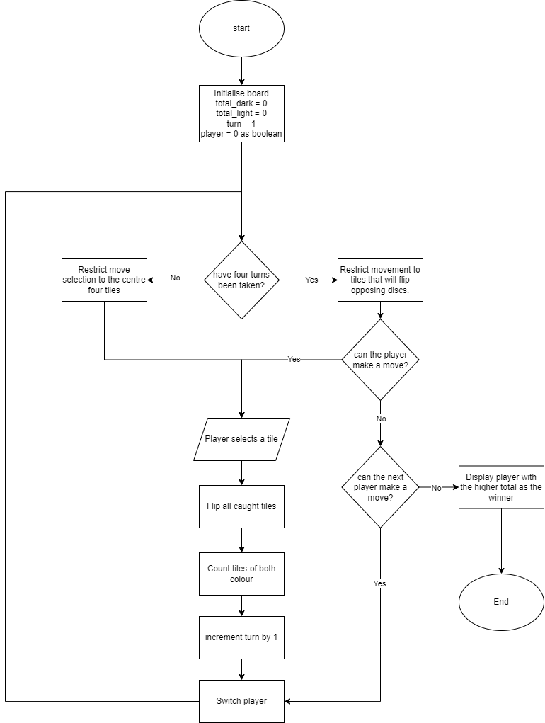

Tile Check Algorithm
